**IoT based Healthcare Monitoring System**

**Milind Mishra1, Shubham Kumar2, Mritunjay Sharma3, Paveen Kumar M.B4,**

**Dr. Shreesha Kalkoor M5**

*5Associate Professor, 12345Department of Electronics and Communication Engineering*

*12345Sambhram Institute of Technology, Visvesvaraya Technological University*

**ABSTRACT**

*Healthcare patient monitoring system is an IoT device which can be used by anyone to check on real time health readings such as temperature, blood pressure and electro- cardiogram could be monitored remotely on a handy device. The device will automatically send alerts to the concerned in case of an emergency which here can be fluctuations in the readings of the sensors beyond normal range of operation. The device is built using pulse sensor, temperature sensor, SpO2 sensor, Humidity sensor, Pressure sensor, Air quality sensor, Toxic gas sensor attached to an Arduino which can transfer its data to servers using WiFi module as well as send SMS updates using the GSM module. The servers can compute the data and present the data on hand held devices.*

***Keywords :*** *Healthcare, Monitoring system, controller, sensors, IoT on cloud platform, Medical services.*

**I. INTRODUCTION**

Health is characterised as a full state of physical, mental, and social well-being and not merely a lack of illness. Health is a fundamental element of people’s need for a better life. Unfortunately, the global health problem has created a dilemma because of certain factors, such as poor health services, the presence of large gaps between rural and urban areas, physicians, and nurses unavailability during the hardest time. IoT is making any objects internally connected in the recent decade and it has been considered as the next technological revolution. Smart health monitoring mechanism, smart parking, smart home, smart city, smart climate, industrial sites, and agricultural fields are some of the applications of IoT. The most tremendous use of IoT is in healthcare management which provides health and environment condition tracking facilities. IoT is nothing but linking computers to the internet utilising sensors and networks. These connected components can be used on devices for health monitoring. The used sensors then forward the information to distant locations like M2M, which are machinery for computers, machines for people, handheld devices, or smartphones. It is a simple, energy-efficient, much smarter, scalable, and interoperable way of tracking and optimising care to any health problem. Nowadays, modern systems are providing a flexible interface, assistant devices, and mental health management to lead a smart life for the human being. Heart rate and body temperature are the two most significant indicators for human health. Heart rate is the per-minute amount of heartbeats, commonly known as the pulse rate. To measure the pulse rate, an increase in the blood flow volume can be used by calculating the pulses. Normal heart rate ranges between 60 and 100 beats per minute for healthy people. The typical restful heart for adult males is roughly 70 bpm and for adult females 75 bpm. Female with 12 years of age and above, typically have higher rates of heart in contrast with males. The temperature of human body is simply the heat of body and the sum of heat radiated by the body is scientifically determined. The average person’s body temperature relies on different factors such as ambient temperature, the person’s gender, and his eating habits. In healthy adults, it is likely to range between 97.8 °F (36.5 °C) and 99 °F (37.2 °C). Different factors such as fu, low-temperature hypothermia, or any other illness may lead to a change in body temperature. In almost all illnesses, fever is a typical indicator. Various methods exist to invasively and non invasively assess the heart rate and body temperature. For the consumer, noninvasive approaches over a while have proven accurate and convenient. It is suggested that a healthcare should provide good room conditions to facilitate the patients. Some measures like room humidity, level of all gases like CO, and CO2 can determine the quality of room environment. The toxic gases and certain levels of humidity are very harmful to patients. For optimum comfort, the room humidity should be between 30 and 65%. Some studies are done only for a smart home, not for dedicated healthcare. There are several fatal diseases like heart disease, diabetes, breast cancer, liver disorder, etc. in medical sector but the main concern of our developed system is to monitor the fundamental signs of all types of patients and the patient’s room environment. This paper proposes a customised healthcare system that monitors the pulse and body temperature of patients as well as room humidity, CO, and CO2 gas level of patient’s room via sensors and transmits the data through Wi-Fi that enables the medical staffs to get data from the server. The developed system also provides a solution for the problem of maintaining a single database of patients in hospitals using a web server, apart from the personalisation of critical health-related criteria. In this system, the gas sensor is used to identify an unexpected occurrence that contrasts the performance with the threshold and produces a PPM signal if the output value crosses the threshold.

**II. LITERATURE SURVEY**

Tamilselvi et al. developed a health monitoring system which is able to monitor basic symptoms of a patient like pulse, percentage of oxygen saturation, temperature, and eye movement in IoT network. For this purpose, the system used Heartbeat, SpO2, Temperature, and response sensors as capturing elements and Arduino-UNO as a processing device. The developed system was implemented but no performance measures are described for any patient

Acharya et al. introduced a healthcare monitoring kit in IoT environment. The developed system monitored some basic parameters of human health like Heartbeat, ECG, temperature of body, and Respiration. The key hardware components which are used here are pulse sensor, temperature sensor, BP sensor, ECG sensor, and raspberry pi. The information were collected from sensors and sent it to raspberry pi for processing and again transmitted it to IoT network. The foremost important drawback of the system is that no interfaces for data visualisation are developed.

Banerjee et al. proposed an important sign detection system supported a noninvasive technique. The proposed system used plethysmography process and correspondingly displayed the output digitally that made it a real-time monitor. The tactic has proved as reliable for the patient compared to other invasive techniques.

Gregoskietal. Introduced a smartphone-based heart monitoring system. The system used a mobile light and camera to trace finger blood flow and calculated blood flow-based rate of flow. The developed system described an integrated device that wirelessly transmitted a person’s pulse to a computer, empowering people to check their sign by merely viewing at their phones instead using hands on every occasion. this can be often an wonderful design but it's isn't feasible if continuous heart monitoring is require

Oresko et al. mentioned a completely upset sensing system for smartphones, identifying a tool that's is developed to be the identical given sufficient time and monetary resources. The developed prototype only tracked coronary rhythm in real-time, didn't track surrender time, and may not detect any upset.

Trivedi et al. suggested a mobile device regulated Arduino-based health parameter surveillance framework. The collected sensor data are analog and sent it to the board of Arduino Uno. By the integrated analog to digital converter, the recorded analog values are converted into digital data. Bluetooth transmitted the physical qualities to the developed device. The Bluetooth device used a module not covering a decent area.

Kathikamani R et al. designed monitoring system for patients using wireless technology. The data collected are stored on the cloud and are analysed. The drawback was not using web service application peripheral interface, it was on localhost. Using the above literature papers as a base, a design is proposed which fulfils the drawbacks of all the systems and was implemented.

**III. METHODOLOGY, COMPONENTS & BLOCK DIAGRAM**

The system consists of the basic vital sensors interfacing with the cloud and mobile application as shown in figure 1. The data is captured by sensors are sent to the processor Arduino where the data is acquired and processed. The data acquired by the processor is compared with the threshold values of the desired sensors. If the sensor values move equal or above the threshold, then an emergency message or alert is passed to the doctors in the mobile application through a Wi- Fi module with the details of each sensor. This data is further passed to the cloud for details changes of the past few hours data. The past few hours can be accessed on the website and the data is stored in the cloud.

The proposed system uses the sensors like pulse sensor (for measuring the heart rate), Temperature sensor (for measuring the body temperature) and SpO2 sensor (for measuring the SpO2 intake) as shown in figure1. The system measures the parameters in real-time and displays on the LCD and in the cloud which enables monitoring of patient health when the doctor is with the patient or wireless monitoring for any place. The flowchart of the proposed system continuous monitoring of the patient is shown in figure 2. The sensors data is sent to the cloud via the Wi-Fi module, if the sensors data are not in acceptable range then an alert message is sent onto the mobile application. The doctor can take the action very soon for helping the patients.

The basic hardware needed for the proposed model is pulse sensor, Temperature sensor, SpO2 sensor and Wi-Fi module, Humidity sensor, pressure sensor, Air quality sensor, Toxic gas sensor, GPS and GSM module.

*Pulse sensor:* it measures the heart rate. It has circuitry for noise cancellation. A finger is placed on the sensor; it calculates the amount of blood in the capillary tube based on the amount of light reflected. The difference in the amount of light transmission and reflection is the result of the sensor.

*Temperature sensor:* The sensor measures the body temperature from -55 degree celsius to +150 degree Celsius. For every 10 degrees rise in temperature, the output changes by 10mv.

SpO2 sensor: This sensor measures the oxygen content in the blood. A little beam of light passed through the blood within a finger. It measures the amount of change in light absorption.

*Wi-Fi module:* This module allows connectivity of the internet with the embedded applications. It uses the communication protocol. It transmits the values of sensors to the mobile application.

*GSM module:* It’s a GSM modem with TTL output. It’s a standard for the mobile telephones. This module sends the message to the mobile if there is a sensor value crosses the threshold.

*Humidity sensor:* The humidity sensor is a device that senses, measures, and reports the relative humidity (RH) of air or determines the amount of water vapour present in gas mixture (air) or pure gas.

*Pressure sensor:* A pressure sensor is a device for pressure measurement of gases or liquids. Pressure is an expression of the force required to stop a fluid from expanding, and is usually stated in terms of force per unit area. A pressure sensor usually acts as a transducer; it generates a signal as a function of the pressure imposed.

*Air quality sensor:* The air quality sensor is part of the air conditioning system. It measures pollutants, in the form of oxidisable or reducible gases, in the air outside your car. Oxidisable gases include carbon monoxide, hydrocarbons (vapours from benzene or petrol) and other partially burnt fuel components.

*Toxic gas sensor:* Toxic gas detectors are used in work places that use toxic gas in order to secure worker safety, detect the location of any leakage, and measure gas concentrations.

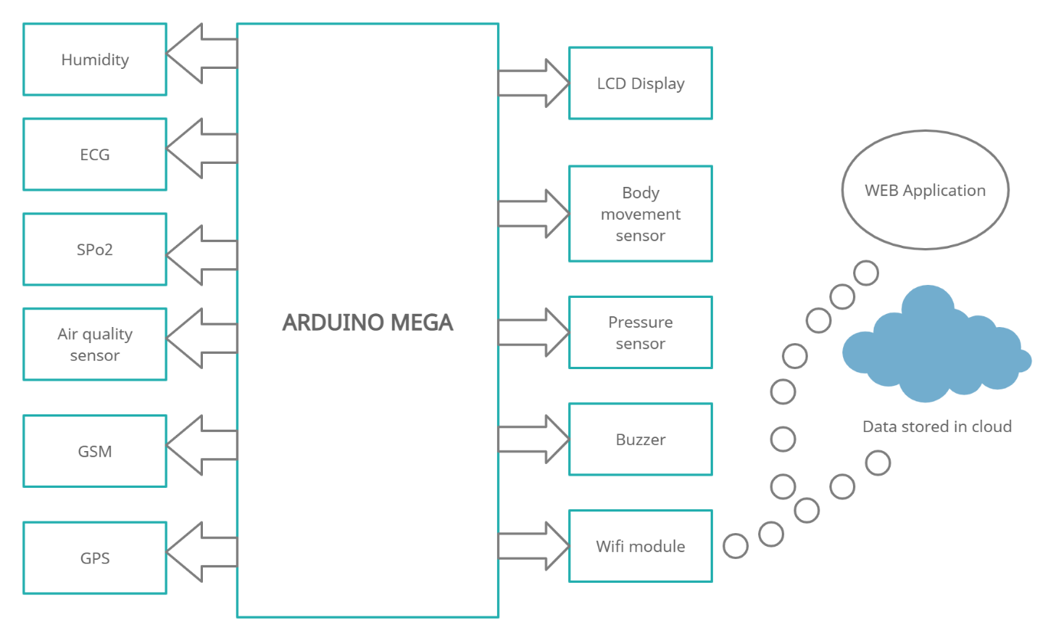

*Figure 1 : Block Diagram*

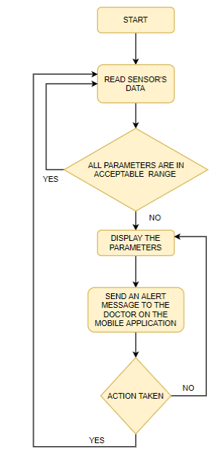

*Figure 2 : Flow Chart*

**IV. RESULT**

The data were collected from sensors and sent to microcontroller for processing and again transmitted it to the customised cloud IoT network. Customised cloud/web server is used for the graphical interpretation, and display of collected results. Web-app shows the current status and process of transactions.The HTTP protocol provides easy connectivity for the correspondence between a Wi-Fi module and the cloud/web server.The HTML user interface is updated every 15sec, allowing patients to be tracked in real- time.

All connected devices and medical equipment are controlled and linked with networks using hardware supported by ESP8266 board. In case of interface for doctors and medical team, the COVID - 19 patient data visualisation. Customised web app gives extensive functions to monitor and control the data received from the patient centre via remote connection.As soon as web-app starts running on device, real time as well as historical data measurements related to patient health e.g body temperature, Blood pressure, Oxygen level, Electrocardiogram, etc. can be seen at any place via remote connectivity. The described paper with IoT system has potential to manage effective operations at hospitals, test laboratories, medicinal distributors and government offices.

**V. CONCLUSION**

This system introduced smart healthcare to monitor the basic important signs of patients like heart rate, body temperature, and some measures of hospital room’s condition such as room humidity. Authentic medical staff can view and track the data in real-time even though the patients perform the tests outside of the hospital. The system can also benefit nurses and doctors in situations of epidemics or crises as raw medical data can be analysed in a short time. The developed system will improve the current healthcare system that may monitor preventing lots of lives from death.

**REFRENCES**

[1] Mohamed Abdel-Basset Abdo, “Structural Health Monitoring, History, Applications and Future. A Review Book,” Edition First, ISBN 978-1-941926-07-9, January 2014 with 5,205 Reads. Online Available : https://www.researchgate.net/publication/266854280_Struc tural_Health_Monitoring_History_Applications_and_Future_A_Review_Book

[2] Amandeep Kaur, Ashish Jasuja, “Health Monitoring Based on IoT using RASPBERRY PI” International Conference on Computing, Communication and Automation (ICCCA2017), ISBN:978-1-5090- 6471-7/17/ ©2017 IEEE

[3] M.Shamim Hossaina Ghulam Muhammad “Cloud-assisted Industrial Internet of Things (IIoT) – Enabled framework for health monitoring”.

[4] Shyamal Patel “A review of wearable sensors and systems with application in rehabilitation” Journal of Neuro Engineering and Rehabilitation Northeastern University.

[5] S. M. Riazul Islam UWB Wireless Communications Research Center, Inha University, Incheon, Korea The Internet of Things for Health Care: A Comprehensive Survey

[6] E. GELOGO JIN WOO PARK SCH. “Internet of Things (IoT) Driven U-health care System Architecture” CATHOLIC UNIV. OF DAEGU, DAEGU, SOUTH KOREA

[7] Suhas Kale and C. S. Khandelwal “Design and implementation of real time embedded tele-health monitoring system” international conference on circuits, power and computing technologies, 2013

[8] V. Tripathi and F. Shakeel, "Monitoring Health Care System Using Internet of Things - An Immaculate Pairing," 2017 International Conference on Next Generation Computing and Information Systems (ICNGCIS), Jammu, 2017, pp. 153-158.

[9] M. Hamim, S. Paul, S. I. Hoque, M. N. Rahman and I. Baqee, "IoT Based Remote Health Monitoring System for Patients and Elderly People," 2019 International Conference on Robotics,Electrical and Signal Processing Techniques (ICREST), Dhaka, Bangladesh, 2019, pp. 533-538.

[10] Luca Catarinucci, Danilo de Donno, Luca Mainetti, Luca Palano, Luigi Patrono, Maria Laura Stefanizzi, e Luciano Tarricone. “An IoTAware Architecture for Smart Healthcare Systems”. IEEE JOURNAL, Dec 2015.